Creating Groups with ORM Stack

Contents

1. Introduction 3
2. Workflow diagram to deploy the stack 3
3. Create stack for Group 4
4. Plan the Job 8
5. Apply the Job 9
6. Verify in the Console 10
7. Destroy the stack (if required) 11

Introduction

In Oracle Cloud Infrastructure (OCI) Identity and Access Management (IAM), groups are a way to organize and manage sets of users. Groups enable’s to define a collection of users who share a common set of permissions, making it easier to manage access to resources at scale.

- Used to grant privileges to cloud resources.
- When creating a group, provide a unique, unchangeable name for the group.
- The name must be unique across all groups within your tenancy.
- Also provide the group with a description (although it can be an empty string), which is a non-unique, changeable description for the group.
- Creates a new group in the ‘Default’ Domain (other secondary Domains) tenancy.

Workflow diagram to deploy the stack

Below diagram shows how the Terraform Artifact are applied in the OCI. While creating a ORM stack, using terraform deliverables Init, Plan and Apply is the flow to provision the resource in the OCI. We can have the deliverables in any of below.
- GitLab/GitHub Repo
- Bitbucket
- Can be in folder/.zip in the local disk
- Object Storage Bucket
- Can be in compartment.
- Oracle provided Template.


Create stack for Group

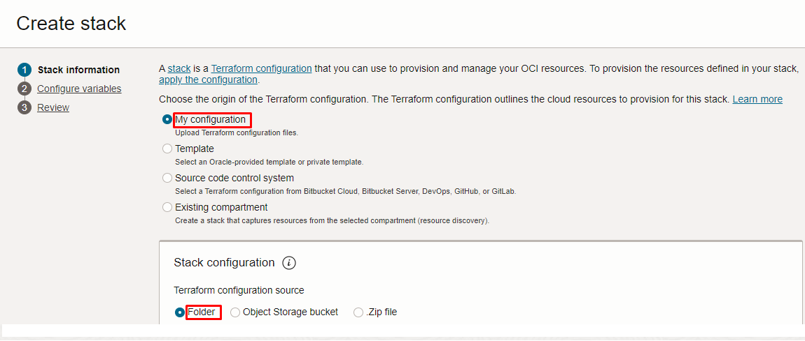

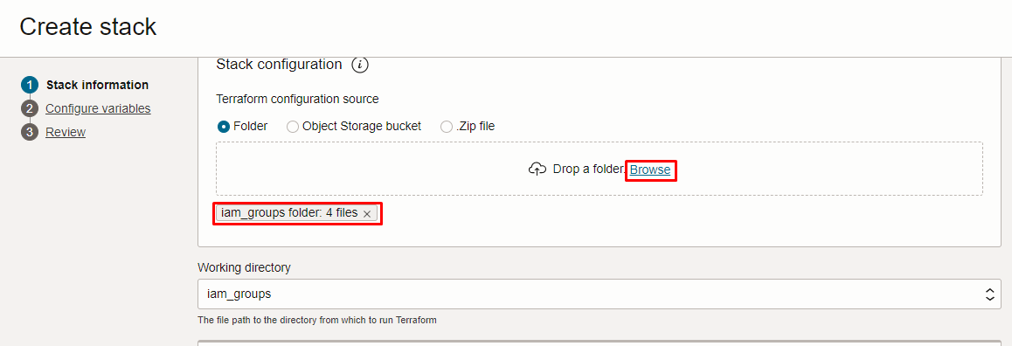

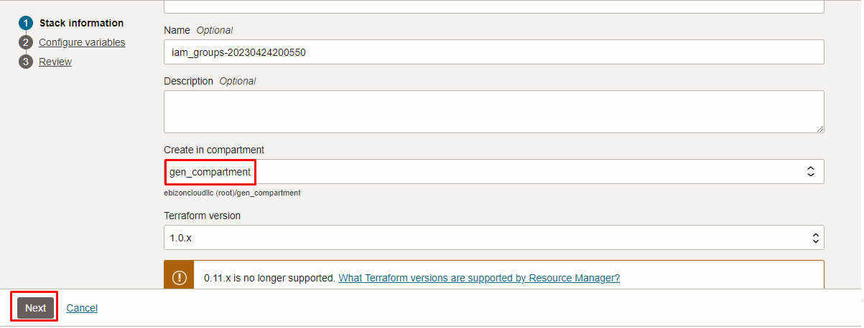

Click “NEXT”

Select the parameters as per the below screen,

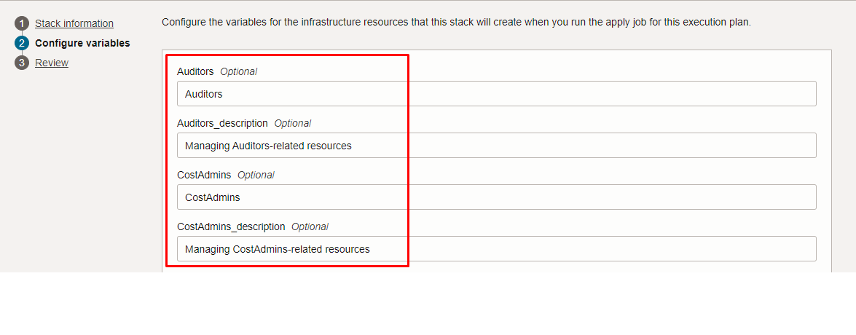

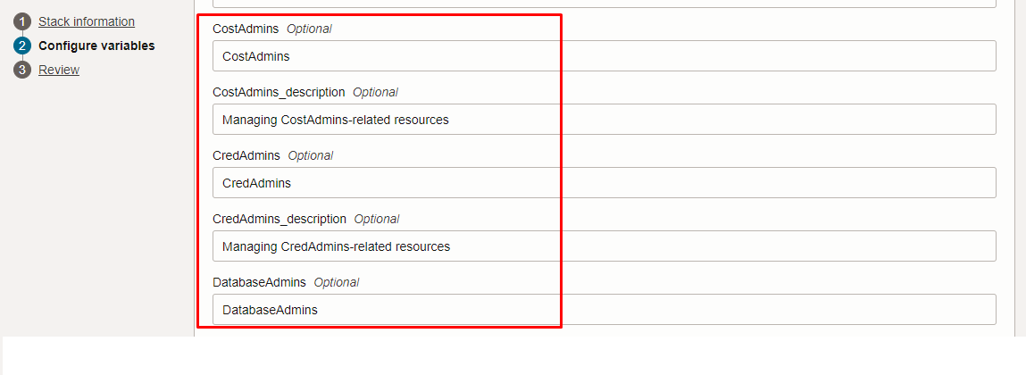

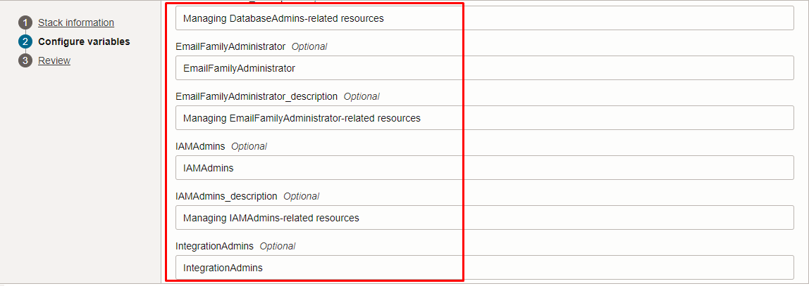

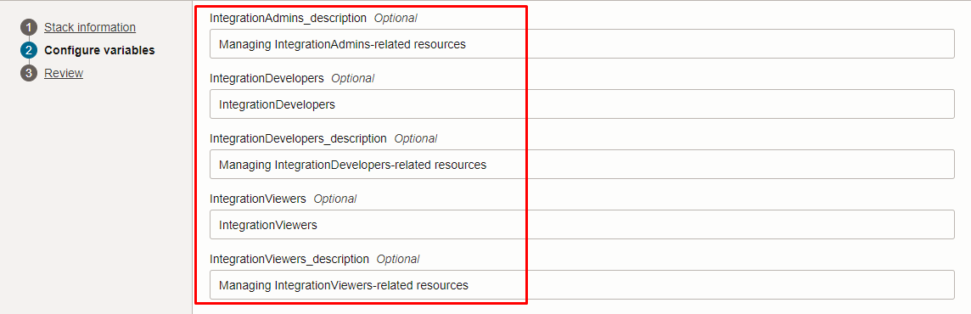

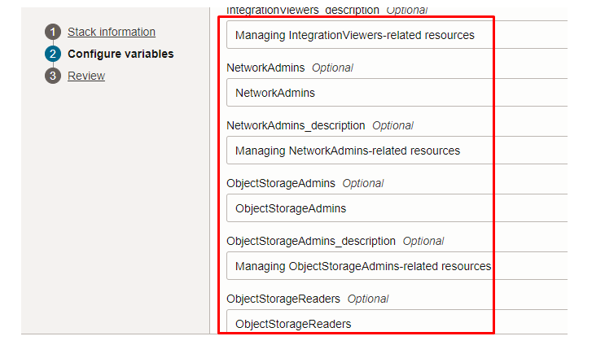

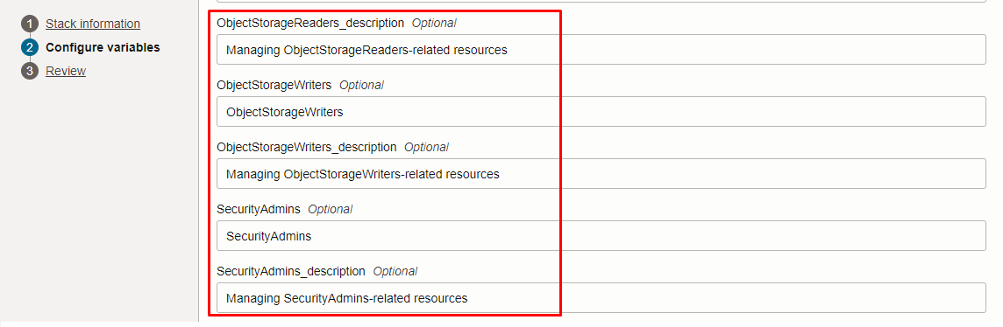

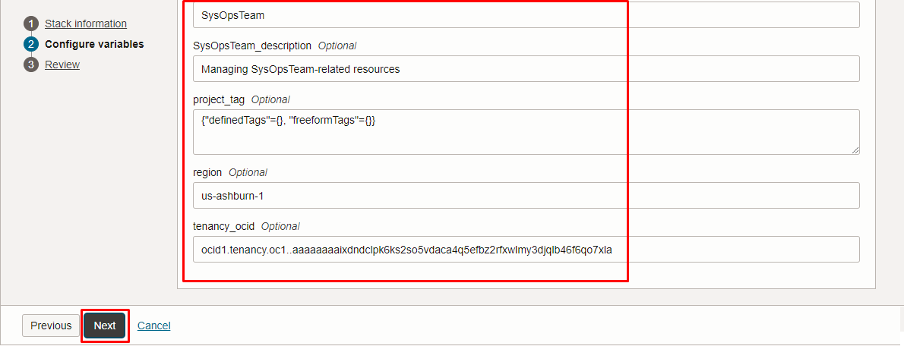

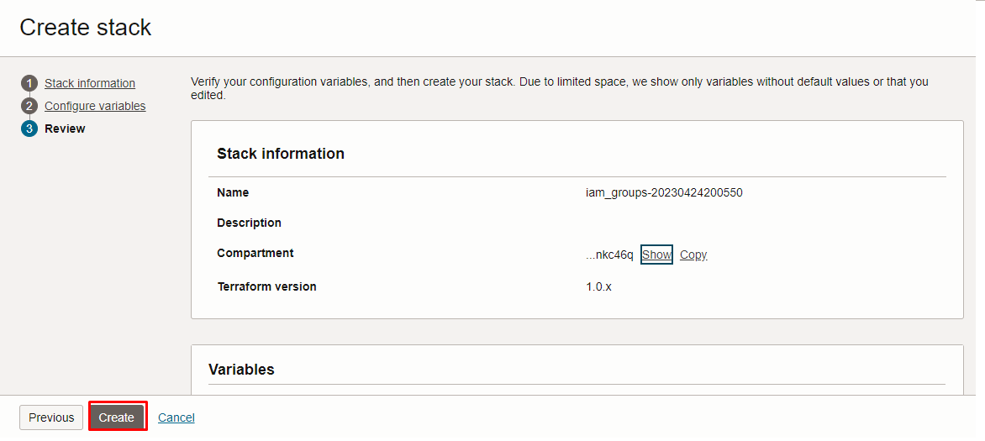

Note: select the right compartment to apply the stack in the OCI

Click “NEXT” Click “CREATE”.

Plan the Job

Click the “Plan”

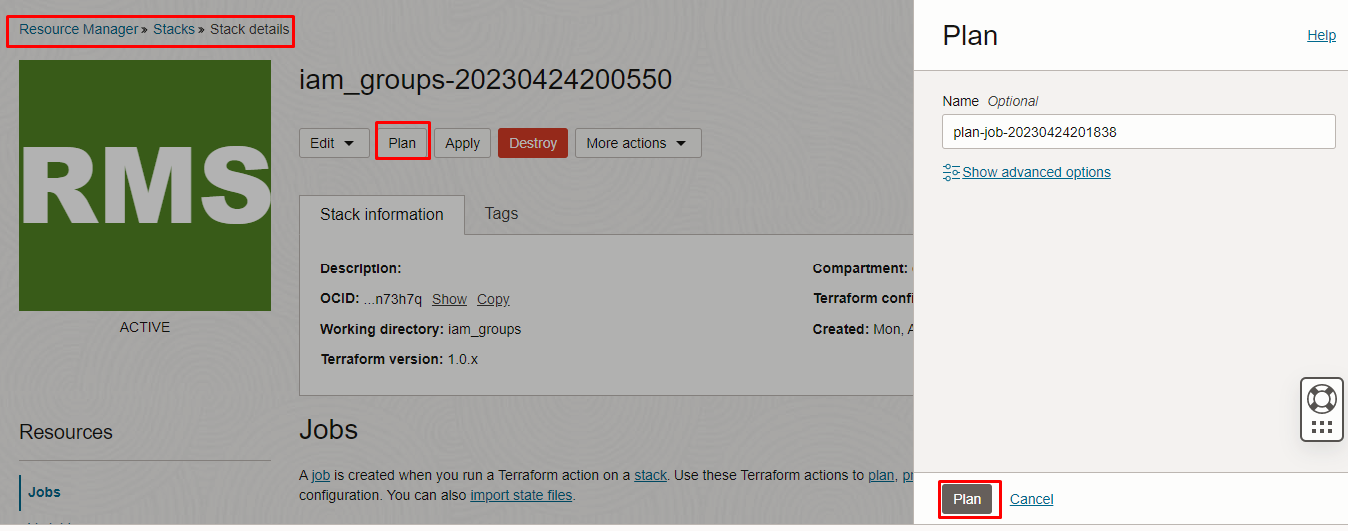

Verify the Plan is successful.

Apply the Job

Once the “plan” is success, now click “Apply”.

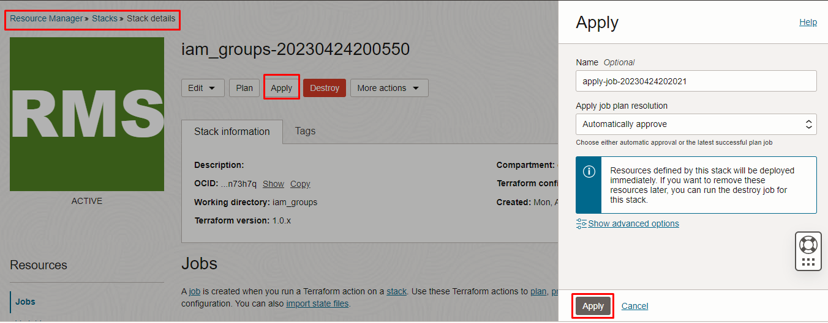

Verify the Apply is successful.
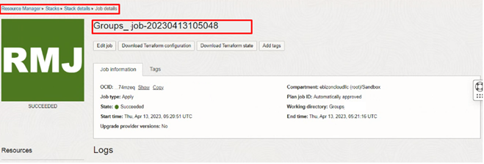

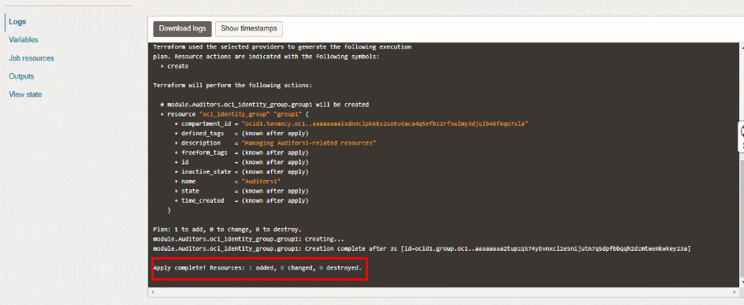

Verify in the Console

Go to OCI Console Identity & Security Domains select the “Default” Domain Groups

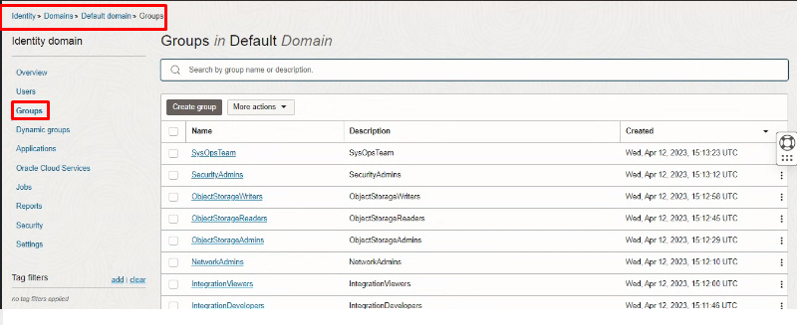
Now verity the below are created.

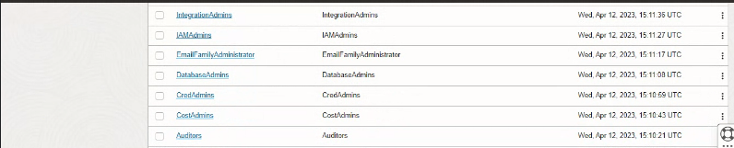

Destroy the stack (if required)

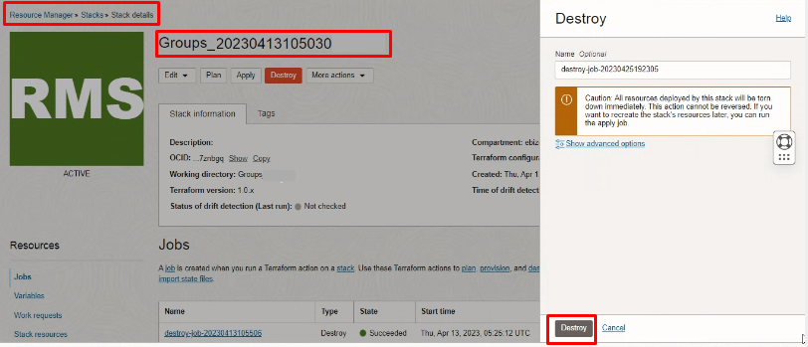

Create a destroy job in Resource Manager to destroy the resources associated with a stack and clean up the tenancy. Once the stack is destroyed then data cannot be recovered from resources. And Stack can also be deleted or keep it for future reference.

# END #

